University of Kent
May/June 2021

Examination Answer Booklet
Before starting this examination, you MUST enter your Examination Number above (double click); failure to provide this means your mark cannot be recorded and you may be awarded a 0 (zero) for this examination.
Re-save the answer booklet to include your exam number in the file name, using the following format: [your exam number] [module code] AnswerBooklet (e.g. 123456 XX123 AnswerBooklet).
Answer one question per page. You may add additional pages to this document if necessary.

Question Number | 1a
Add your answer below:
First Line:
π 4p(4 -> 5) = π 5p(5 -> 4)
Second Line:
P(5 -> 4) = (1/5 * 1/2) / (1 – 1/10 – 1/10 – 1/5 – 1/5)
Question Number | 1b
Add your answer below:
To implement an AND gate in the game of life, there needs to be two separate inputs and one output. There also needs to be a gun in which it fires a constant stream of gliders and eaters to block the gliders where needed, to allow a signal in the output only when both inputs have a signal. Meaning that if either input 1 or input 2 have a signal, there will not be an output, which also applies if there is no signal for both. For instance, as shown in the truth table below for an AND gate:
Input 1 | Input 2 | Output
0 | 0 | 0
1 | 0 | 0
0 | 1 | 0
1 | 1 | 1

Input 1 = 0 and Input 2 = 0:
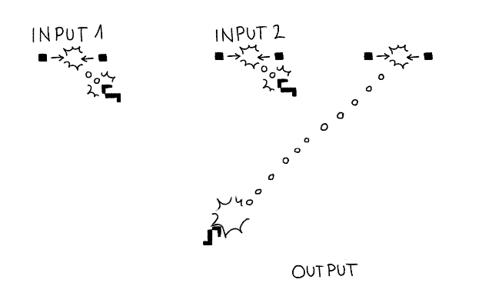
As shown above, it shows no signal from input 1 and no signal from input 2, as they are blocked by eaters, with the stream from the gun continuing to the eater. Therefore, there is no output.
Input 1 = 1 and Input 2 = 0:
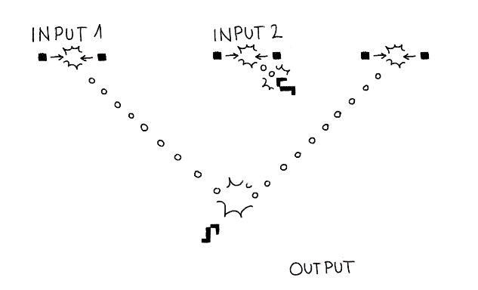
As shown above, there is a signal from input 1 and no signal from input 2, as input 2 is blocked by the eater. The signal from input 1 hits the original stream from the gun, annihilating the stream. Therefore, there is no output.
Input 1 = 0 and Input 2 = 1:
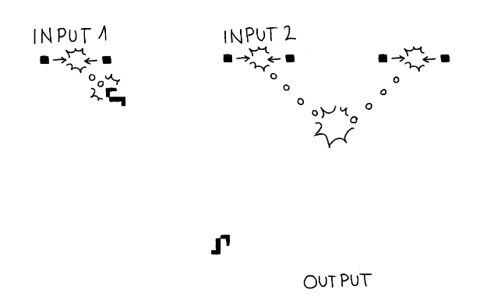
As shown above, there is no signal from input 1 and a signal from input 2, as input 1 is blocked by the eater. The signal from input 2 hits the original stream from the gun, annihilating the stream. Therefore, there is no output.
Input 1 = 1 and Input 2 = 1:
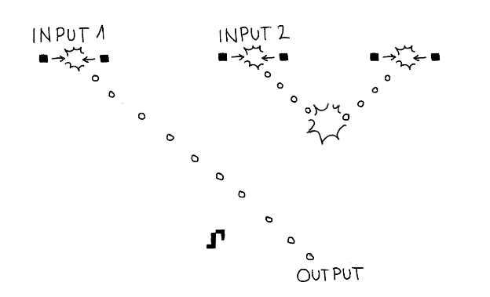
As shown above, there is a signal from input 1 and a signal from input 2. The signal from input 2 hits the original stream, annihilating the stream. This gives space for the stream from input 1 to continue. Therefore, there finally is an output.
From the explanations above of the graphical representations, it is observed how they are in line with the truth table for the AND gate.
Question Number | 1c
Add your answer below:
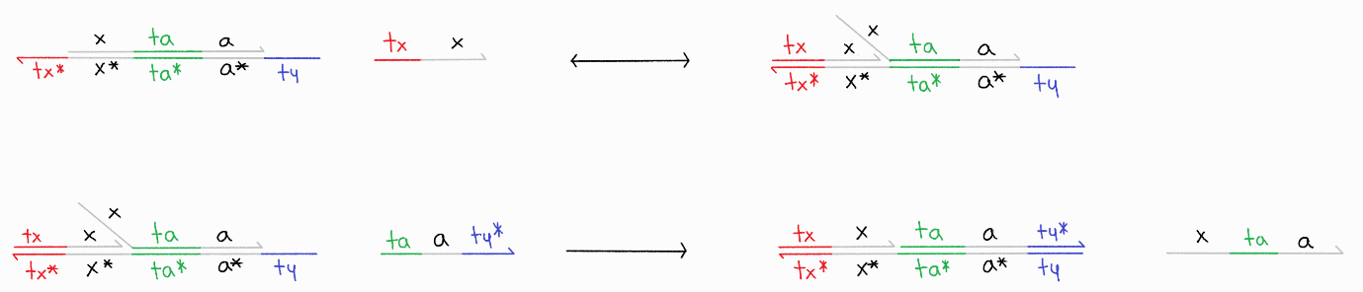

Question Number | 2a
Add your answer below:
After one update, the population has the possibility of outputting:
- (A,B) | (A,D)
- (A,B) | (C,B)
- (A,D) | (C,D)
- (C,B) | (C,D)
Question Number | 2b
Add your answer below:
The states in question 2a are currently not steady states, however it is possible that they can be a steady state after a number of updates. For instance, the states (A,B) | (A,B) and (A,D) | (A,D) are the steady states that are possible.
Question Number | 2c
Add your answer below:
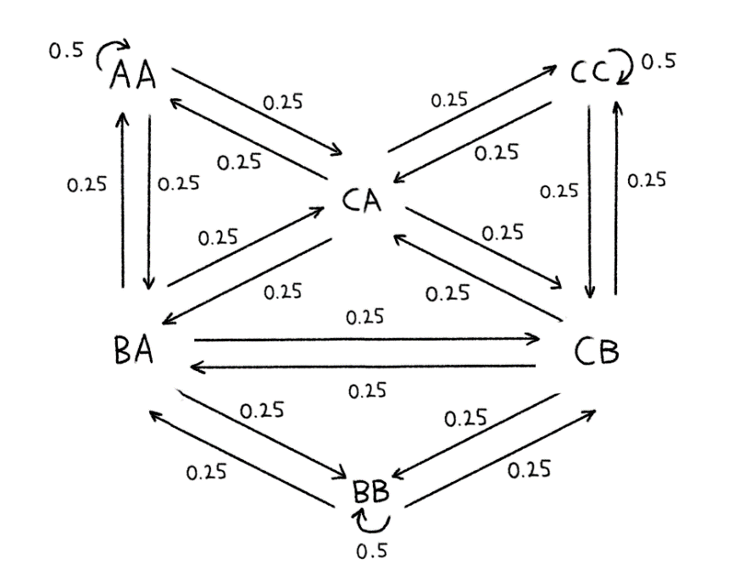
Workings for State Transition AA to AA:
pAcc = min(1, (2/3) / (2/3))
tProb = pAcc * ½
tProb = 1 * ½
tProb = ½
Question Number | 4a
Add your answer below:
- The graph would be populated with 10 nodes (P₁ to P₁₀) representing the customers in which the products are to be delivered to plus one node representing the depot, which would be the starting node. Ants are only able to visit 5 customers in a single walk.

These nodes are interconnected with all other nodes through the means of which the artificial ant would travel to, these means are through pheromones that determine the individual ant’s probability of travel.

These pheromones are represented in the edges in which the nodes are connected through. With this means of travel, the edges of the node the artificial ant has taken will be incrementally added to the eventual complete candidate solution.

- In order to calculate the local heuristic function, the price of a node needs to be divided by the distance from the current node to the closest node. This is done so it can minimise the value of D (distance travelled) and/or maximise the value of C (cost for the customer). So, it would give a higher heuristic function value, or it would reduce the value of the heuristic function.

- The complete candidate solution: (D_{t} / C_{t})
Question Number | 4b
Add your answer below:
A and B are non-dominated
C is dominated by A, B and D
D is dominated by A and B

